# POLE 1 Converter Transformer weekly Gas Analysis:

## From 8-07-2021 to 15-07-2021

## YYA CONVERTER TRANSFORMER:



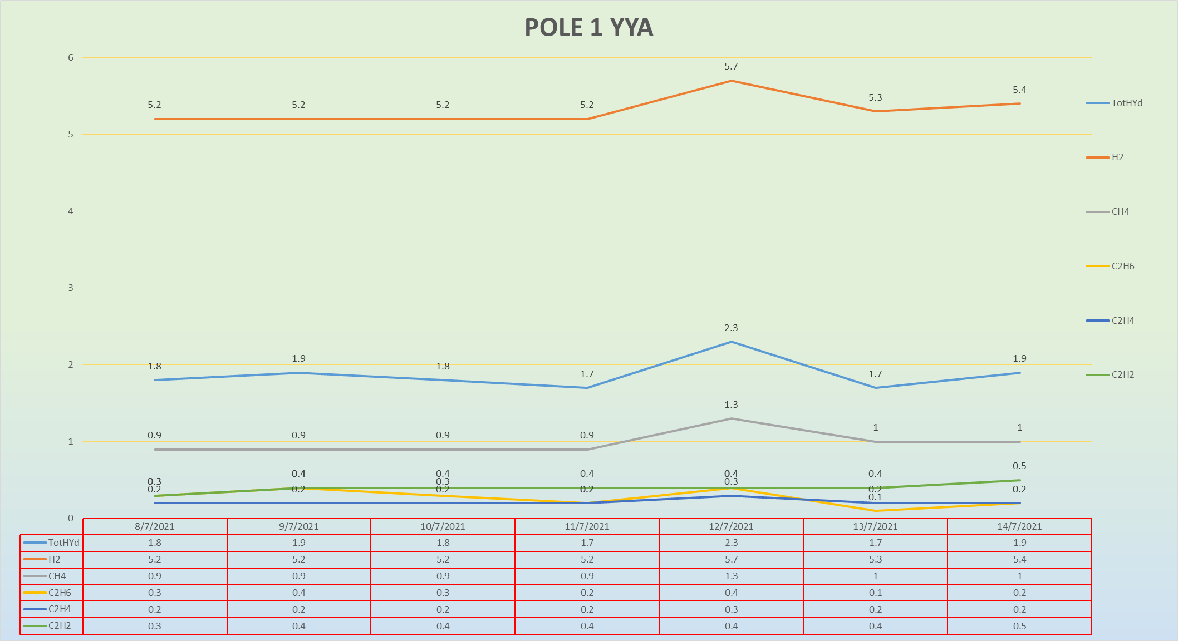

### POLE 1 YYA TotHyd Variation:

### POLE 1 YYA H2 Variation:

### POLE 1 YYA CH4 Variation:

### POLE 1 YYA C2H6 Variation:

### POLE 1 YYA C2H4 Variation:

### POLE 1 YYA C2H2 Variation:

## YYB CONVERTER TRANSFORMER:



### POLE 1 YYB TotHYD Variation:

### POLE 1 YYB H2 Variation:

### POLE 1 YYB CH4 Variation:

### POLE 1 YYB C2H6 Variation:

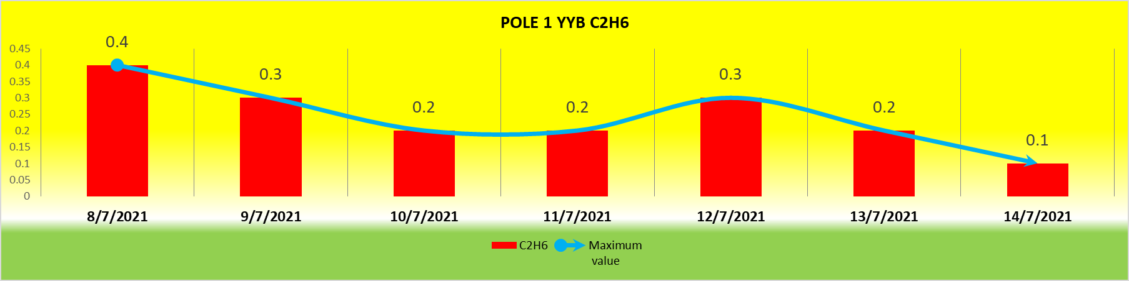

### POLE 1 YYB C2H4 Variation:

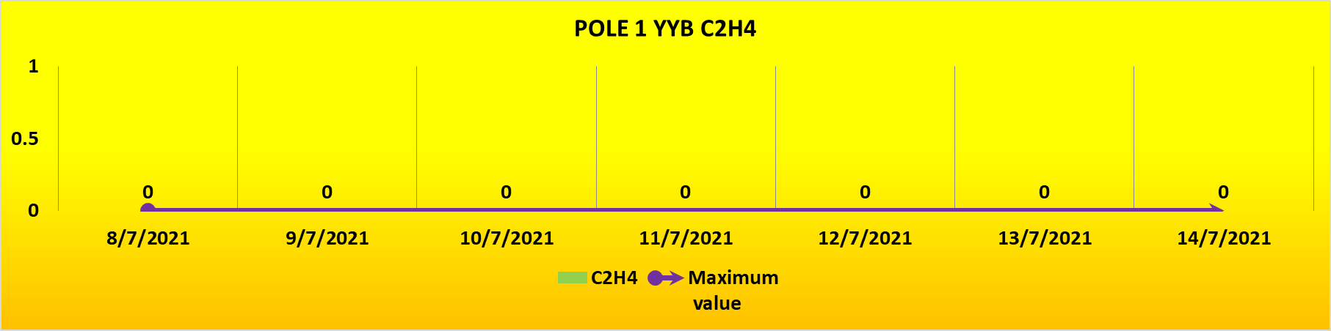

### POLE 1 YYB C2H2 Variation:

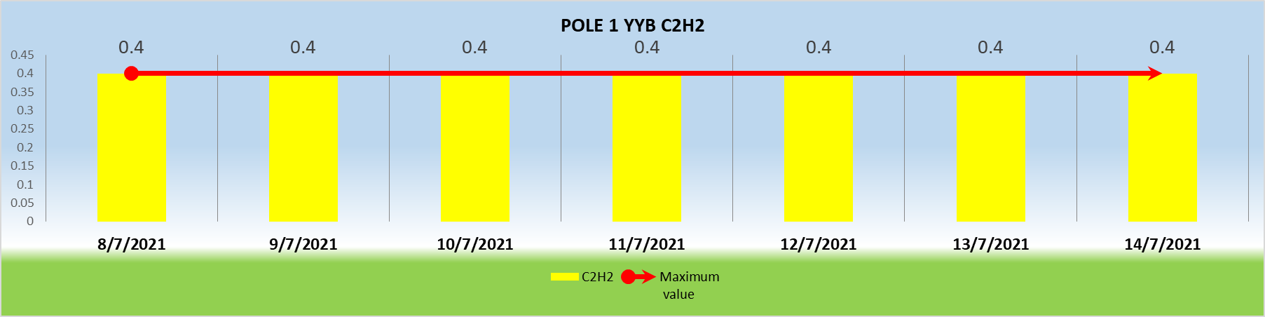

## YYC CONVERTER TRANSFORMER:



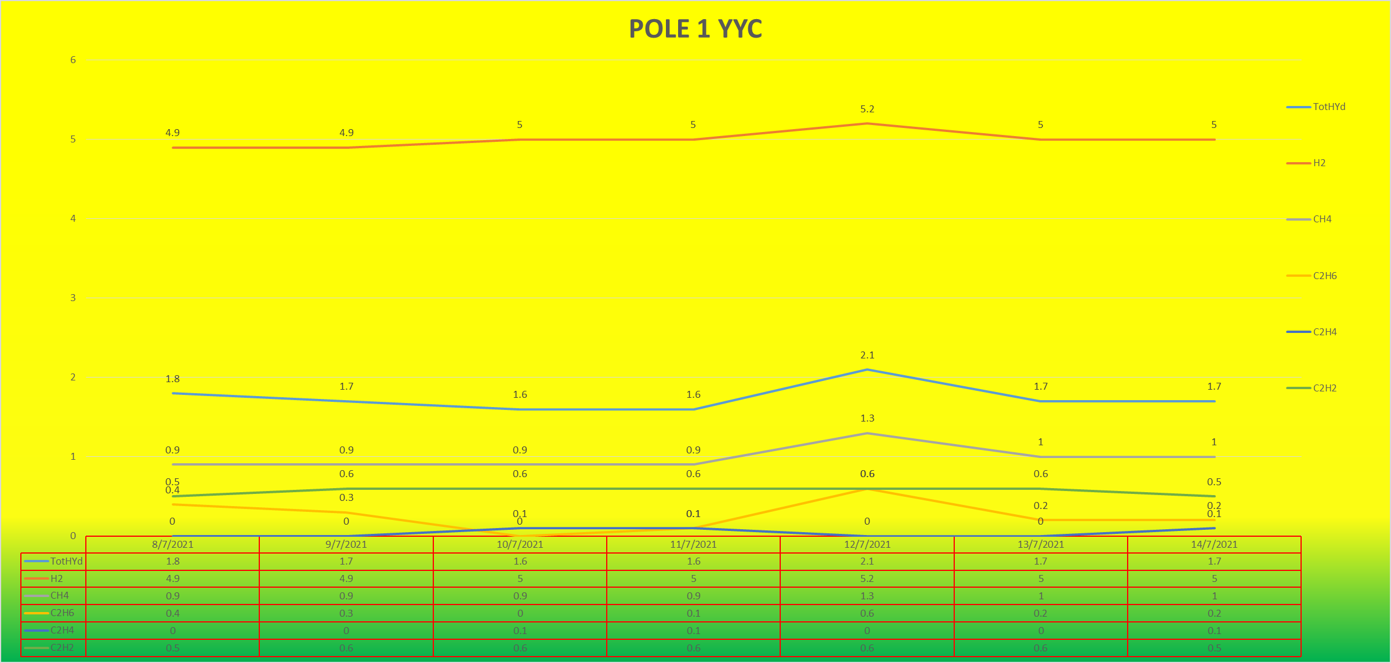

### POLE 1 YYC TotHYD Variation:

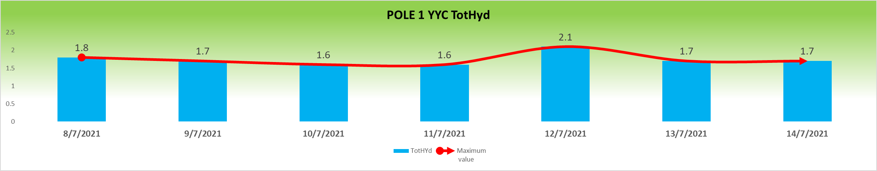

### POLE 1 YYC H2 Variation:

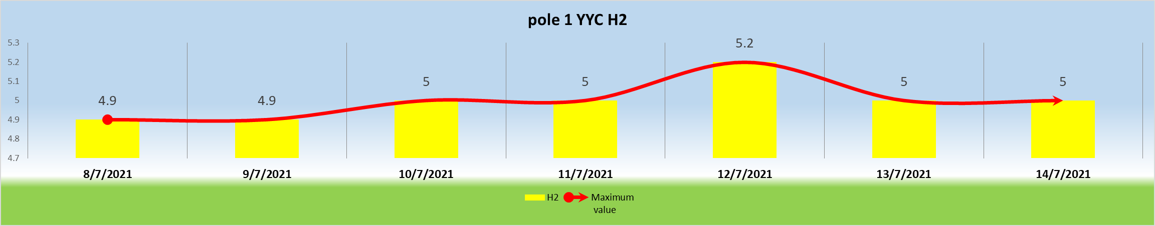

### POLE 1 YYC CH4 Variation:

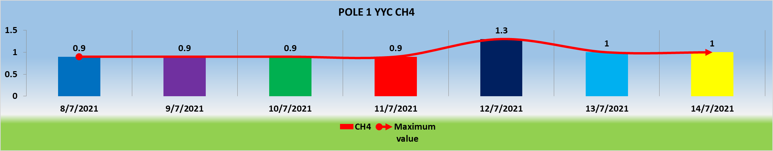

### POLE 1 YYC C2H6 Variation:

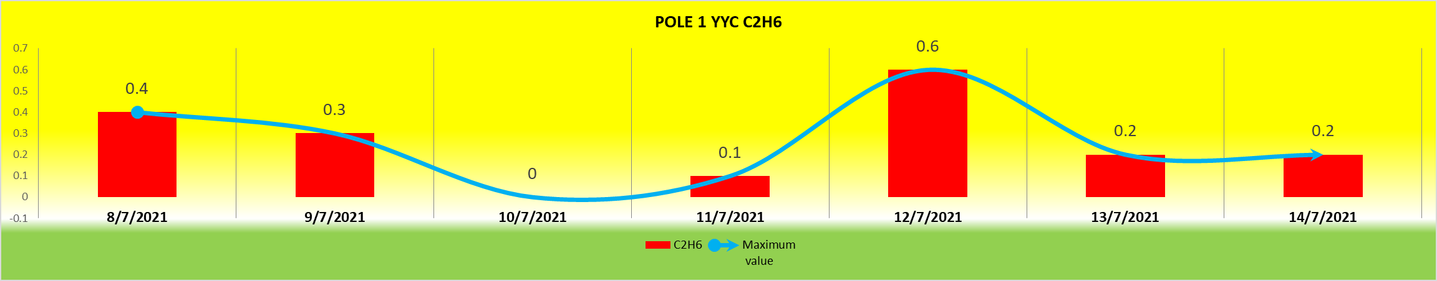

### POLE 1 YYC C2H4 Variation:

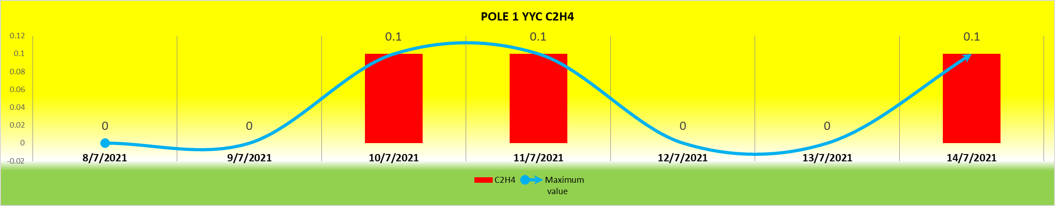

### POLE 1 YYC C2H2 Variation:

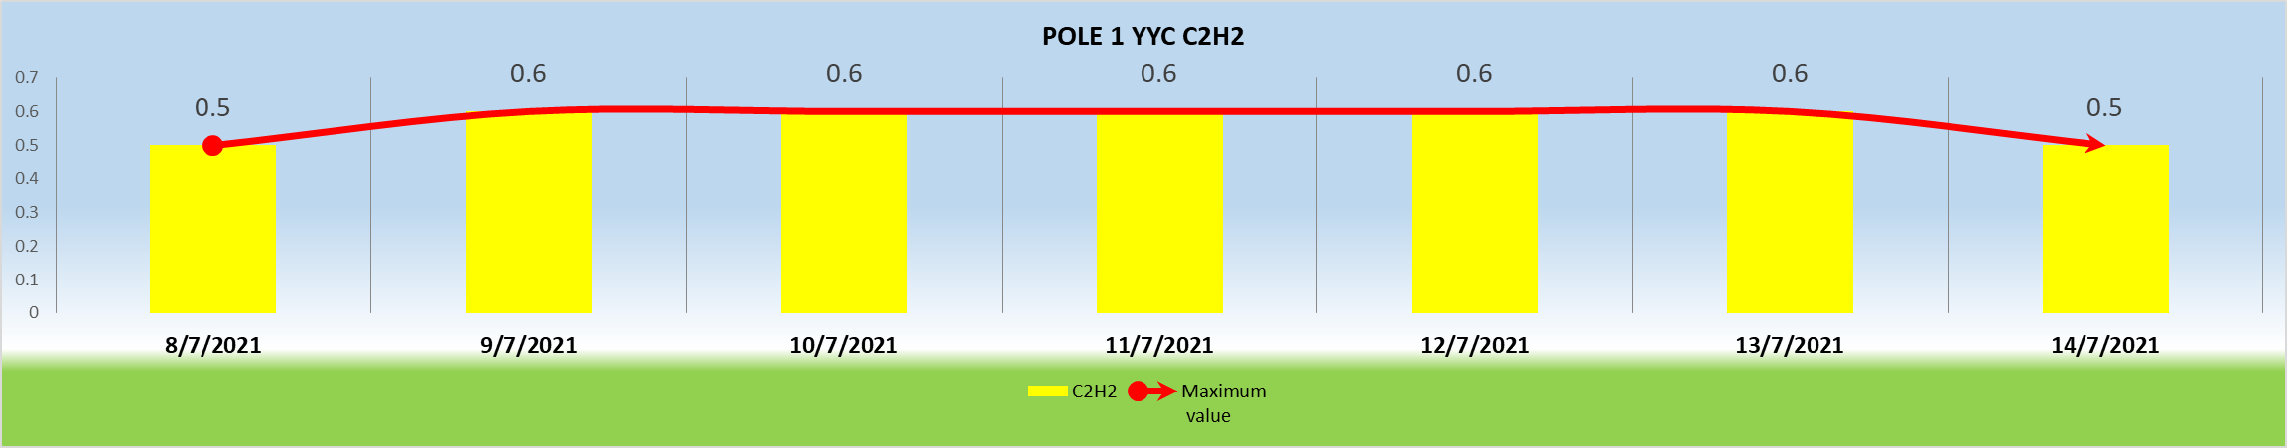

## YDA CONVERTER TRANSFORMER:



